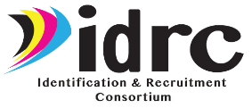
IDRC State Director Checklist
Year 1 (October 1, 2023-September 30, 2024)

State Activities/Evaluation
 | 1 | Collaborate with IDRC and other CIG states through resource sharing, mentoring, and sending/virtual sharing of recruiters to assist/provide technical assistance. Provide information about interstate collaboration on Form 1: IDRC Director Survey and submit by 9/25/24.
 | 2 | Establish/expand partnerships with farmworker agencies, employers, and other programs serving migratory children/youth and their families in your state to facilitate ID&R. Describe your state’s partnerships on Form 1: IDRC Director Survey and submit by 9/25/24.
 | 3 | Utilize the IDRC Recruiter Assessment to assess recruiters/ID&R staff in your state and use the results to inform PD on ID&R. Indicate the number of recruiters/ID&R staff in your state that took the Assessment/received PD on ID&R on Form 1: IDRC Director Survey and describe how your state utilized the results of the Assessment to inform PD on Form 1 and submit by 9/25/24.
 | 4 | Participate in IDRC professional development (e.g., webinars, in-person training, Targeted Response to ID&R [TRI] efforts, new director mentoring, Professional Learning Groups [PLGs]). Complete evaluations of each PD using Form 2: IDRC Training Evaluation.
 | 5 | Participate in IDRC State Steering Team (SST) and Technical Support Team (TST) meetings. Complete evaluations of each meeting using Form 3: IDRC Meeting Evaluation. Following are the Year 1 SST and TST meetings:  - SST Meeting #1 (virtual) on October 19, 2023  - SST Meeting #2 (date/location to be determined)  - TST Meeting #1 in Kansas City, MO on November 14-15, 2023  - TST Meeting #2 (virtual) (date/time to be determined)  TST Meeting #3 (date/location to be determined)
 | 6 | At the end of the summer, distribute the QR code/link to Form 4: ID&R Staff Survey so ID&R staff can complete the online survey by 9/25/24.
 | 7 | Complete all items on Form 1: IDRC Director Survey and submit by 9/25/24.
 | 8 | Submit (via email) your state’s signed cover sheet (ED 524B) for the Year 1 Annual Performance Report to Cari by 12/1/24.
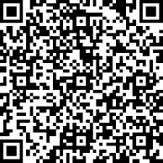
QR Code/Link to Form 1: IDRC Director Survey
https://www.surveymonkey.com/r/IDRCDirectorSurvey23-24

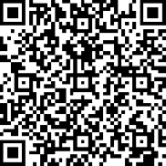
QR Code/Link to Form 2: IDRC Training Evaluation
https://www.surveymonkey.com/r/IDRCTrainingEval23-24

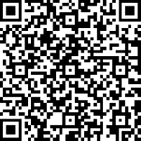
QR Code/Link to Form 3: IDRC Meeting Evaluation
https://www.surveymonkey.com/r/IDRCMeetingEval23-24

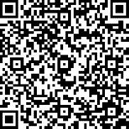
QR Code/Link to Form 4: IDRC-ID&R Staff Survey
https://www.surveymonkey.com/r/IDRC-IDRStaffSurvey23-24

